i

HOME SECURITY SYSTEM

MUHAMAD HAFIZ BIN NORROSNAN

This report is submitted in partial fulfillment of the requirements for the award of

Bachelor of Electronic Engineering(Industrial Electronics) With Honours

Faculty of Electronic and Computer Engineering

Universiti Teknikal Malaysia Melaka

April 2010





**UNIVERSTI TEKNIKAL MALAYSIA MELAKA**

FAKULTI KEJURUTERAAN ELEKTRONIK DAN KEJURUTERAAN KOMPUTER

**BORANG PENGESAHAN STATUS LAPORAN**

**PROJEK SARJANA MUDA II**

**Tajuk Projek** : HOME SECURITY SYSTEM

|  |  |  |  |  |  |  |  |  |
| --- | --- | --- | --- | --- | --- | --- | --- | --- |
| **Sesi** | : | 0 | 9 | / | 1 | 0 |  |  |
| **Pengajian** |  |  |  |  |  |  |  |
|  |  |  |  |  |  |  |  |
| Saya MUHAMAD HAFIZ BIN NORROSNAN | | | | | | | |  |
|  |  |  |  |  |  | (HURUF BESAR) | |  |

mengaku membenarkan Laporan Projek Sarjana Muda ini disimpan di Perpustakaan dengan syarat-syarat kegunaan seperti berikut:

1. Laporan adalah hakmilik Universiti Teknikal Malaysia Melaka.
2. Perpustakaan dibenarkan membuat salinan untuk tujuan pengajian sahaja.
3. Perpustakaan dibenarkan membuat salinan laporan ini sebagai bahan pertukaran antara institusi pengajian tinggi.
4. Sila tandakan ( **√** ) :

*(Mengandungi maklumat yang berdarjah keselamatan atau

**SULIT\*** kepentingan Malaysia seperti yang termaktub di dalam AKTA RAHSIA RASMI 1972)

**(Mengandungi maklumat terhad yang telah ditentukan oleh

**TERHAD\*\***

organisasi/badan di mana penyelidikan dijalankan)

**TIDAK TERHAD**

Disahkan oleh:

__________________________

(TANDATANGAN PENULIS)

___________________________________

(COP DAN TANDATANGAN PENYELIA)

Tarikh: ……………………….. Tarikh: ………………………..



ii

“I hereby declare that this report is result of my own effort except for quotes as cited in

the references.”

Signature : ……………………………….

Author : MUHAMAD HAFIZ BIN NORROSNAN

Date :



iii

“I hereby declare that I have read this report and in my opinion this report is sufficient in

terms of the scope and quality for the award of Bachelor of Electronic Engineering

(Industrial Electronics) With Honors.”

Signature : ……………………………….

Supervisor’s Name : ENCIK HAZLI RAFIS BIN ABD RAHIM

Date :



iv

For my lovely mum and dad, thanks for your sacrifice towards my success.

For my supervisor, En. Hazli Rafis Bin Abd Rahim, thanks for all your

supports.

To my friends who’s helped me lots, I’ll appreciate very much



v

**ACKNOWLEDGEMENT**

First and foremost, I would like to give Thanks to ALLAH SWT, for helping me. I would like to express my appreciation to my supervisor, Mr.. Hazli Rafis Bin Abd Rahim for her support and guidance throughout this whole project.

To my beloved parents who always give me support and never tired of convincing me in order to achieve my determination and finishing my study without any delay. They always support me and understand me while giving me opportunity in completing all my projects.

Besides that, I am also thankful to all the lecturers that also giving me some ideas and knowledge that can be used to accomplish the PSM project. Not forgotten to my friends who had also helped me in giving their thought, pro and contra of each of the research and result that I had obtained.

Once again for the last time, I would like to express my gratitude to those people that already mentioned above as well as the BENE’s student of Electronic and Computer Engineering Faculty who provide many suggestions, information, and criticism and sustain in this report.



vi

**ABSTRACT**

This is a digital home security system which can monitor gas sensor, motion sensor,vibration sensor and magnetic switch (windows & doors). The goal of this project is to utilize the after-market parts and build an integrated home security system. Besides traditional magnetic switch equipped on doors and windows, This system have also incorporated gas sensor, motion sensor, vibration sensor and magnetic switch. Hence the security system will sound an alert when there is an attempt of break-in or if there is possible smoke or fire. The system is fully digital and also be fully customized. It incorporated a 16x2 LCD display with a 4x4 keypad. Each sensor can be enabled or disabled, and alarm frequency and skim can also be chosen by users.



vii

**ABSTRAK**

Ini adalah merupakan sistem keselamatan rumah digital yang boleh mengawasi dan mengawal sensor gas, sensor pergerakan, sensor getaran dan suis magnet (tetingkap & pintu). Tujuan projek ini adalah untuk membina sistem keselamatan rumah terintegrasi. Selain itu juga system tersebut dilengkapi suis magnet pada pintu dan tingkap, sistem ini juga telah dimasukkan dan dipelbagaikan dengan sensor gas, sensor pergerakan, sensor getaran dan suis magnet. Maka sistem keselamatan akan mengeluarkan suara amaran bila ada usaha pecah masuk atau jika ada kemungkinan asap atau api. Sistem ini merupakan digital sepenunya. Ini dimasukkan dan dilengkapi dengan layar LCD 16x2 dengan keypad 4x4. Setiap sensor boleh dihidupkan atau dimatikan, dan frekuensi penggera dan skim juga boleh dipilih oleh pengguna.



**TABLE OF CONTENTS**

**CHAPTER** **TITLE** **PAGE**

|  |  |  |  |
| --- | --- | --- | --- |
| **I** | **INTRODUCTION** | | **1** |
|  | 1.1 Introduction | | 1 |
|  | 1.2 | Project Summary | 1 |
|  | 1.3 | Problem Objectives | 2 |
|  | 1.4 | Problem Statements | 2 |
|  | 1.5 | Operation Of The Project | 4 |
|  | 1.6 | Sensor Operation | 5 |
|  | 1.7 | Scope Of The Project | 13 |

|  |  |  |  |
| --- | --- | --- | --- |
| **II** | **LITERATURE REVIEW** | | **15** |
|  | 2.1 | Literature review overview | 15 |
|  | 2.2 | Conceptual Logic | 15 |
|  | 2.3 | Circuit Diagram | 16 |
|  | 2.4 | Power Supply | 19 |
|  | 2.5 | Alarm Devices | 21 |
|  | 2.6 | Instrusion Definitions | 23 |
|  | 2.7 | Zone Circuit Logic | 24 |
|  | 2.8 | Keypads | 24 |
|  | 2.9 | PIC16F877 Microcontroller | 26 |



|  |  |  |  |
| --- | --- | --- | --- |
| **III** | **METHODOLOGY** | | **31** |
|  | 3.1 Introduction | | 31 |
|  | 3.2 | Flowchart Description | 32 |
|  | 3.3 | Gantt Chart | 34 |
|  | 3.4 | Expected Results | 35 |

|  |  |  |  |  |
| --- | --- | --- | --- | --- |
| **IV** | **RESULTS AND ANALYSIS** | | | **37** |
|  | 4.1 Introduction | | | 37 |
|  | 4.2 | | Project Result | 37 |
|  | 4.3 | | Hardware Part | 38 |
|  | 4.4 | Software part | | 42 |
|  | 4.5 | Simulation part | | 42 |
|  | 4.6 | | Project Model | 44 |
|  | 4.7 | | Actual Results | 46 |

|  |  |  |  |
| --- | --- | --- | --- |
| **V** | **CONCLUSION AND SUGGESTION** | | **48** |
|  | 5.1 Introduction | | 48 |
|  | 5.2 | Discussion | 48 |
|  | 5.3 | Conclusion | 50 |
|  | 5.4 | Suggestion and Future Work | 51 |
|  | **REFERENCES** | | 52 |
|  | **APPENDIX A** | | 53 |



1

**CHAPTER I**

**INTRODUCTION**

**1.1** **Introduction overview**

This chapter discusses about the project objective, project summary, problem statement and operation this project.

**1.2** **Project Summary**

This is a digital home security system which can monitor gas sensor, motion sensor,vibration sensor and magnetic switch (windows & doors). The goal of this project is to utilize the after-market parts and build an integrated home security system. Besides traditional magnetic switch equipped on doors and windows, This system has also incorporated temperature sensor, smoke detectors, and motion sensor. Hence the security system will sound an alert when there is an attempt of break-in or if there is possible smoke or fire. The system is fully digital and also be fully customized. It incorporated a 16x2 LCD display with a 4x4 keypad. Each



2

sensor can be enabled or disabled, and alarm frequency and skim can also be chosen by users.

**1.3** **Project Objectives**

The main objective of the home security system is to introduce the system to the user to monitor the safety of their homes from burglary. In addition, to introduce the system using PIC Microcontroller to control and monitor all of the houses**.** This is objectives of the project will be implemented :

* To create and developed a effective home security system.
* To design home security system using PIC Microcontroller.
* To find suitable circuit and electronic component to build that system.
* To know how the operation of circuit home security system.
* To prove how that system can be used in the house.

**1.4** **Problem Statements**

Security systems are a popular means of crime deterrence in modern society; since most people believe that criminals disregard houses armed with alarm systems. As the market for security systems expanded, the technology and resulting features available in home security systems has also sky-rocketed. Unfortunately, many security system customers are left with a multi-thousand dollar alarm system that they are unable to effectively operate.

A majority of security systems currently on the marked retain the archaic keypad interface. Aside from a few exceptions, most of the more complex features of the alarm system are available only through strange, difficult to learn, and certainly difficult to remember numeric keypad combinations. Most security systems also continue to make use of only a couple of LEDs to indicate the



3

current status of the system. With recent technological innovations, alarm systems have the capability to report or display far more information than "armed" or "unarmed". Unfortunately, these advances in technology and features have not been accompanied with suitable interface designs.

In order to accomplish this, there must attempt to recognize as many shortcomings in current system interfaces as possible, and attempt to correct these, as well as implement a superior status display system capable of easily imparting more information to the user. There are a number of user needs in the area of security variations that the system should address. Not all users will demand the same type of security, nor do all users want this security at the same time. Additionally, their rationale for desiring this security may vary depending on their possessions or requirements for safety.

The system should be able to provide appropriate levels of security while occupants are away from their residence. This feature, while it is considered a general requirement for all systems, may prove especially helpful for those who put in irregular hours at their place of employment, those who vacation on a regular basis, or even for those who like to do yardwork yet don't like to lock their doors behind them all the time.

Not only do users wish for their belongings to be secure while they are away from their homes, but some actually require that their security systems to add an extra level of security while they are at home. This seemed to be a desirable feature among female respondents who spend time in their homes alone, but it must not be limited as a feature to female users. This feature seems justifyable for use in homes where children spend periods of time alone, or in households during sleeping hours.



4

Other modes of system alertness can vary based on who is in the house. For example, babysitters or housekeepers may wish to secure the house in a more simple manner than someone going to sleep or leaving the house for vacation. The system must be accessible and usable for more than one specified user; it must allow for the needs of all who may occupy the house/property- not just the homeowner.

Finally, much attention has been given to securing the house itself, but for users who desire the safeguarding of items that are not only in their house but on the premises, features must allow for arming of circuits outside of the house. Some applications of this could be the arming of entrances to carports and garages, supply closets, tool sheds, and backyards. In addition, users may wish for this feature to exclude uninvited parties from their property so as to avoid liability claims, such as negligence to safeguard a swimming pool or dangerous equipment.

**1.5** **Operation Of The Project**

This is a home security system controlled by Panel 1. Panel 1 is brain or main board which uses PIC to control sensor used. That system use IC PIC16F877 component. That system using some sensor to be used to detect any reaction. Sensor used is smoke sensor , temperature sensor and motion sensor. Panel 1 can monitors between one and eight entry/exit points (zones) of a building or room. This system can allows monitoring to be totally or partially suspended when required by the legitimate guardians (users) of the premises. The system can allows users to change PIN code and allow users to access the control systems without using a PIN code in the event of system failure or servicing. This system accepts all conventional types of switched-output commercial sensor, including magnetic catches, pressure pads, passive infra-red (PIR) devices, vibration detectors and for any mixture of these to be used. Then,



5

provides anti-tamper warning of interference with the system.This is a block diagram of the Home Security System shown in Figure 1.1: Input : Keypad, Magnetic Switch, Smoke Sensor,Motion Sensor, and Temperature Sensor. Output **:** Buzzer, Strobe,Bell, and LCD.

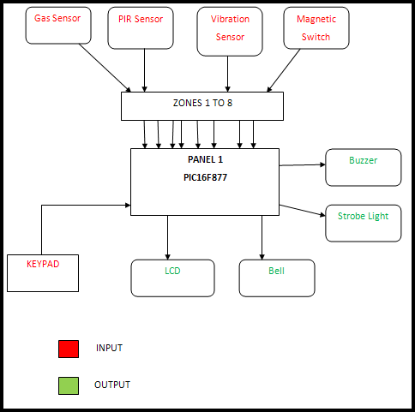

Figure 1.1: Block Diagram of the Home Security Systems

**1.6** **Sensor Operation**

**1.61** **Smoke Sensor**

All smoke detectors consist of two basic parts: a sensor to sense the smoke and a very loud electronic horn to wake people up. Smoke detectors can run off of a 9-volt battery or 120 volt house current. Smoke detector has two way to detect smoke presence such as Photoelectric Detectors and Ionization Detectors.[5]



6

**1.61.1 Photoelectric Detectors**

Occasionally you will walk into a store and a bell will go off as you cross the threshold. If you look you will often notice that a photo beam detector is being used. Near the door on one side of the store is a light (either a white light and a lens, or a low-power laser), and on the other side is a photodetector that can "see" the light. When you cross the beam of light you block it. The photodetector senses the lack of light and triggers a bell. You can imagine that this same sensor could act as a smoke detector. If it ever got smoky enough in the store to block the light beam sufficiently, the bell would go off! There are two problems: 1) it's a pretty big smoke detector, and 2) it is not very sensitive. There would have to be a LOT of smoke before the alarm would go off - the smoke would have to be thick enough to completely block out the light, and that's a lot of smoke.

Photoelectric smoke detectors therefore use light in a different way. Inside the smoke detector there is a light and a sensor, but they are at 90 degree angles to one another, like this: Figure 1.2 as shown below:

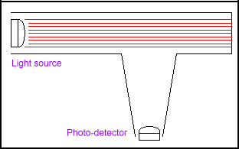

Figure 1.2: The light from the light source on the left shoots straight across and misses the sensor



7

In the normal case, the light from the light source on the left shoots straight across and misses the sensor. When smoke enters the chamber, however, the smoke particles scatter the light and some amount of light hits the sensor. Figure 1.3 as shown below:

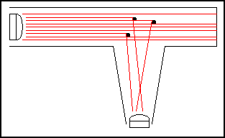

Figure 1.3: The smoke particles scatter the light and

some amount of light hits the sensor

The sensor then sets off the horn in the smoke detector. Photoelectric detectors are better at sensing smoky fires, such as a smoldering mattress.

**1.61.2 Ionization Detectors**

Ionization smoke detectors use an ionization chamber and a source of ionizing radiation to detect smoke. This type of smoke detector is more common because it is inexpensive and better at detecting smaller amounts of smoke produced by flaming fires. Inside an ionization detector is a small amount of Americium-241 (perhaps 1/5000th of a gram). The radioactive element Americium has a half-life of 432 years, and is a good source of alpha particles. Another way to talk about the amount of Americium in the detector is to say that a typical detector contains 0.9



8

microcurie of Americium-241. A curie is a unit of measure for nuclear material. If you are holding a curie of something in your hand, you are holding an amount of material that undergoes 37,000,000,000 nuclear transformations per second. Generally that means that 37,000,000,000 atoms in the sample are decaying and emitting a particle of nuclear radiation (such as an alpha particle) per second. One gram of of the element radium generates approximately one curie of activity (Marie Curie, the woman after whom the curie is named, did much of her research using radium).

An ioniziation chamber is very simple. It consists of 2 plates with a voltage across them, along with a radioactive source of ionizing radiation, like this: Figure 1.4 as shown below:

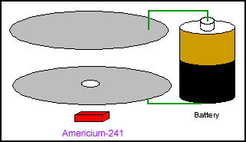

Figure 1.4: voltage across them, along with a radioactive source of ionizing radiation

The alpha particles generated by the Americium have the following property: they ionize the oxygen and nitrogen atoms of the air in the chamber. To ionize means "to knock an electron off of". When you knock an electron off of an atom, you end up with



9

a free electron (with a negative charge) and an atom missing one electron (with a positive charge). The negative electron is attracted to the plate with a positive voltage, and the positive atom is attracted to the plate with a negative voltage (opposites attract, just like with magnets). The electronics in the smoke detector sense the small amount of electrical current that these electrons and ions moving toward the plates represent.

When smoke enters the ionization chamber it disrupts this current - the smoke particles attach to the ions and neutralize them. The smoke detector senses the drop in current between the plates and sets off the horn.

**1.62 Motion Sensor**

A motion detector is a device that monitors a field of view and performs a function if motion is detected within that field. The function might be to trigger the opening of a door, as in the case of a grocery store; start a videotape machine for surveillance; turn on floodlights; or sound an alarm. A motion detector might detect motion through the use of optics or acoustics and can be passive or active. Component used to detect movement is PIR, "Passive Infrared".[4]

PIR sensors allow you to sense motion, almost always used to detect whether a human has moved in or out of the sensors range. They are small, inexpensive, low-power, easy to use and don't wear out. For that reason they are commonly found in appliances and gadgets used in homes or businesses. They are often referred to as PIR, "Passive Infrared", "Pyroelectric", or "IR motion" sensors.



10

PIRs are basically made of a pyroelectric sensor (which you can see above as the round metal can with a rectangular crystal in the center), which can detect levels of infrared radiation. Everything emits some low level radiation, and the hotter something is, the more radiation is emitted. The sensor in a motion detector is actually split in two halves. The reason for that is that we are looking to detect motion (change) not average IR levels. The two halves are wired up so that they cancel each other out. If one half sees more or less IR radiation than the other, the output will swing high or low.

Along with the pyroelectic sensor is a bunch of supporting circuitry, resistors and capacitors. It seems that most small hobbyist sensors use the BISS0001 ("Micro Power PIR Motion Detector IC"), undoubtedly a very inexpensive chip. This chip takes the output of the sensor and does some minor processing on it to emit a digital output pulse from the analog sensor. For many basic projects or products that need to detect when a person has left or entered the area, or has approached, PIR sensors are great. They are low power and low cost, pretty rugged, have a wide lens range, and are easy to interface with.

PIR sensors are more complicated than many of the other sensors explained in these tutorials (like photocells, FSRs and tilt switches) because there are multiple variables that affect the sensors input and output. To begin explaining how a basic sensor works, we'll use this rather nice diagram (if anyone knows where it originates plz let me know).

The PIR sensor itself has two slots in it, each slot is made of a special material that is sensitive to IR. The lens used here is not really doing much and so we see that the two slots can 'see' out pastsome distance (basically the sensitivity of the sensor). When the sensor is idle, both slots detect the same amount of IR, the ambient amount radiated from the room or walls or



11

outdoors. When a warm body like a human or animal passes by, it first intercepts one half of the PIR sensor, which causes a positive differential change between the two halves. When the warm body leaves the sensing area, the reverse happens, whereby the sensor generates a negative differential change. These change pulses are what is detected. Figure 1.5 as shown below:

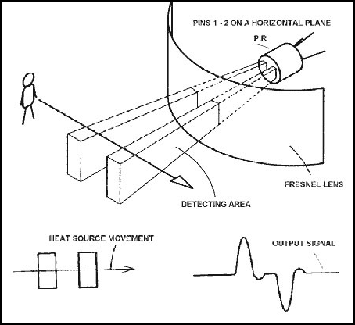

Figure 1.5: When the warm body leaves the sensing area, the reverse happens, whereby

the sensor generates a negative differential change

**1.61 Temperature Sensor**

A temperature sensor is a device that gathers data concerning the temperature from a source and converts it to a form that can be understood either by an observer or another device. Temperature sensors come in many different forms and are used for a wide variety of purposes, from simple home use to extremely accurate and precise scientific use. They play a very important role almost everywhere that they are applied; knowing the



12

temperature helps people to pick their clothing before a walk outside just as it helps chemists to understand the data collected from a complex chemical reaction.[6]

**1.63** **Magnetic Switch**

Magnetic contact switch is a generic term referring to an electrical switch that is operated by a magnetic field. The absence or presence of the magnetic field, provided by a small magnet, opens and closes the switch. In the alarm industry, they are the most common and the most economical form of protection. Generally, there are 3 types of magnetic contact; recessed, surface, and mechanically actuated. The recessed contact shown on the left is the most common in residential applications. The entire switch and magnet are concealed within the fabric of the building and when they are pressed into the 3/8-inch holes drilled for their installation, all that remains visible is a couple of 7/16-inch diameter, slightly raised dots on the esurface. If painted over, they can become very difficult to locate.[7] Figure 1.6 as shown below:

A surface mount contact is shown below with its associated magnet. Both the switch and magnet are visible after installation. These contacts are most common in commercial applications and in residential installations where recessed mounting is not an option. A mechanically actuated switch generally refers to a recessed contact, which requires a physical operation to function. Examples of this are roller, pushbutton, or dome type of contacts. The switch and magnet are integral to the contact and actuated by a physical device (button, dome or roller) that tells the switch the protected item is closed or present. They are somewhat prone to failure or malfunction due to paint or dirt buildup on the mechanism over time.



13

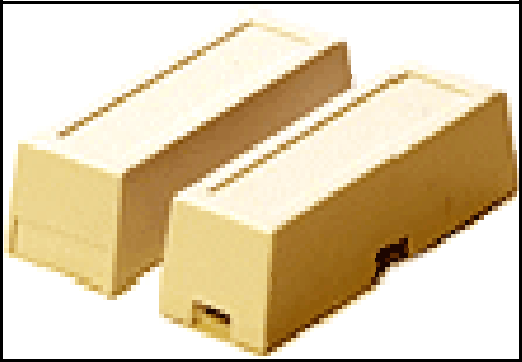

Figure 1.6: Magnetic Switch Device

**1.7** **Scope Of The Project**

The scope of this project is to design the Home Security System . This project mainly focuses on hardware and program. It also has some circuit to control all the sensors and keypad input, output information to LCD screen, indicate system status on LED, and make buzz or voice alarm.

**1.71** **Program**

The hardest part of the program is timing. I use PIC programming by using PIC16F877. The PIC is operated at 3.2768MHz, as set by crystal X1. IT is this rate which determines the accuracy of the software clock that controls the bell-on duration and entry/exit timing. In order to comply with the allocated timings, a different frequency must not be used with this design.



14

**1.72** **Hardware**

In this part, this system is use four types sensors such as gas sensor, motion sensor, vibration sensor ,and magnetic switch attaches to panel 1 main board. Input **:** Keypad, Magnetic Switch, Gas Sensor,Motion Sensor, and Vibration Sensor. Output **:** Buzzer, Strobe Light,Bell, and LCD.

